

**CSE370 : Database Systems**

**Project Report**

**Project Title : Project Title Here**

| **Group No : __, CSE370 Lab Section : __, Summer 2024** | | |
| --- | --- | --- |
| **ID** | **Name** | **Contribution** |
| 24341131 | Mahmudul Hasan Tamal | Routing, Post |
| 22201604 | Priyankan Biswas | DB, Queries |
| 24141244 | Md. Shajjat Hossain Shahat | Home, LogIN, Reg. |
| 21301682 | Siam Abdullah | Chat, Admin |
|  |  |  |

**Table of Contents**

| **Section**  **No** | **Content** | **Page No** |
| --- | --- | --- |
| 1 | ER/EER Diagram | 3 |
| 2 | Schema Diagram | 4 |

**ER/EER Diagram**

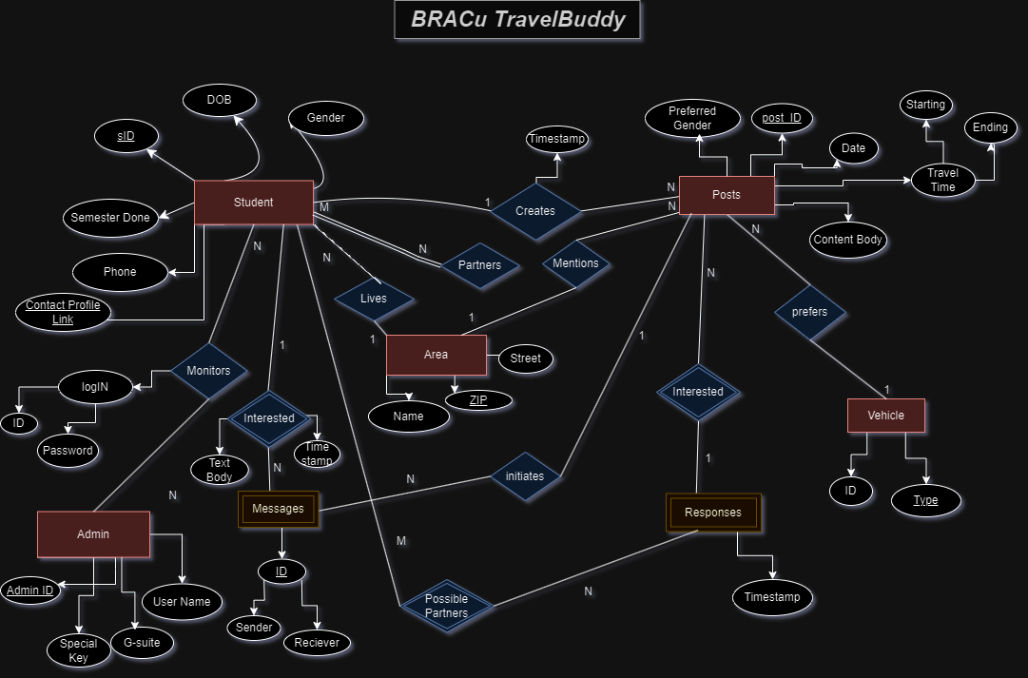

**Schema Diagram**

